PBL

*by* Suraqah Talal

**Submission date:** 18-Apr-2023 08:51PM (UTC+0530)

**Submission ID:** 2068393365

**File name:** PBL_RESEARCH_PAPER_5.docx (2.66M)

**Word count:** 2352

**Character count:** 13555

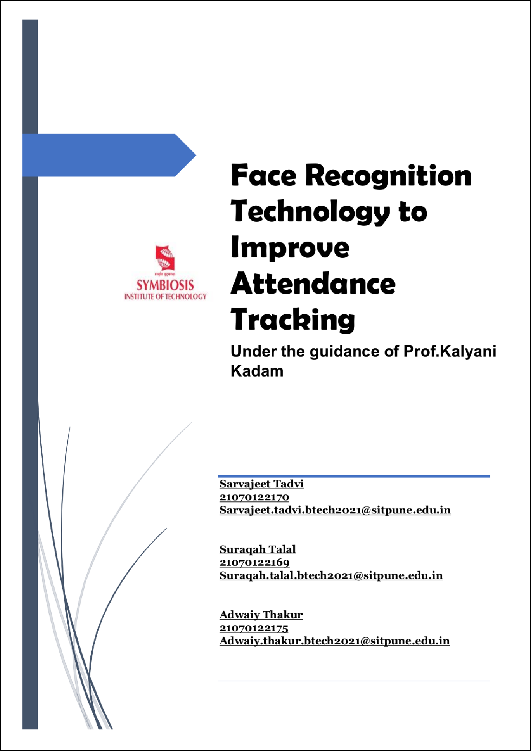

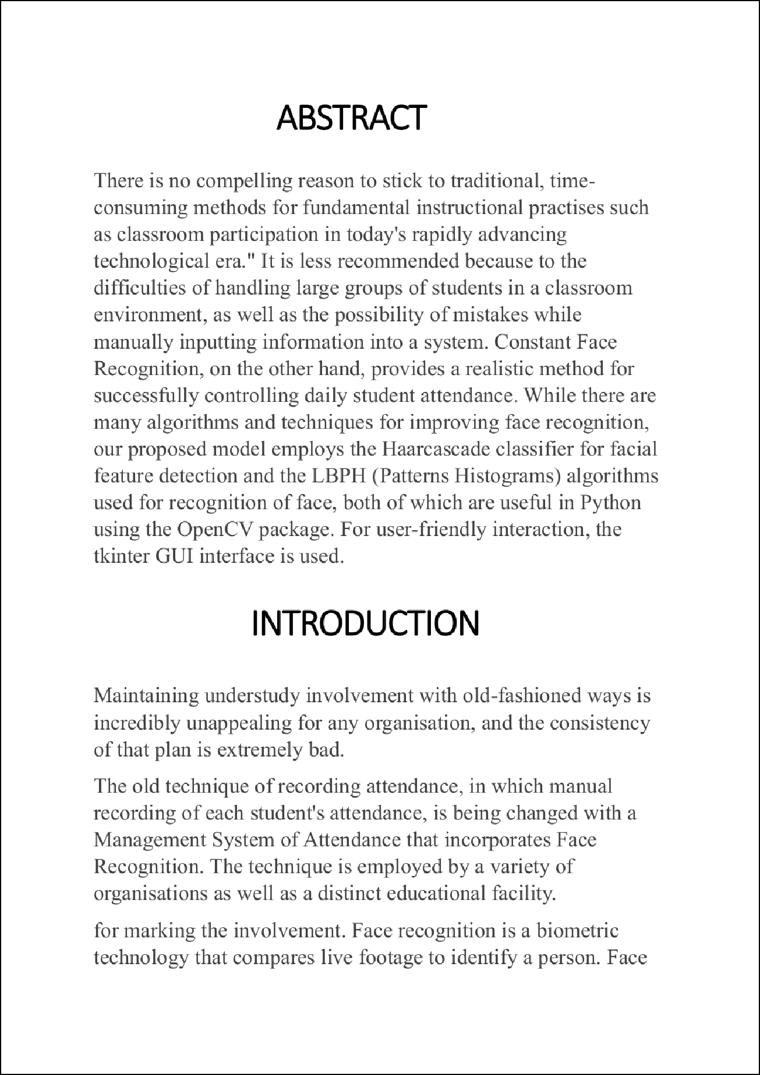

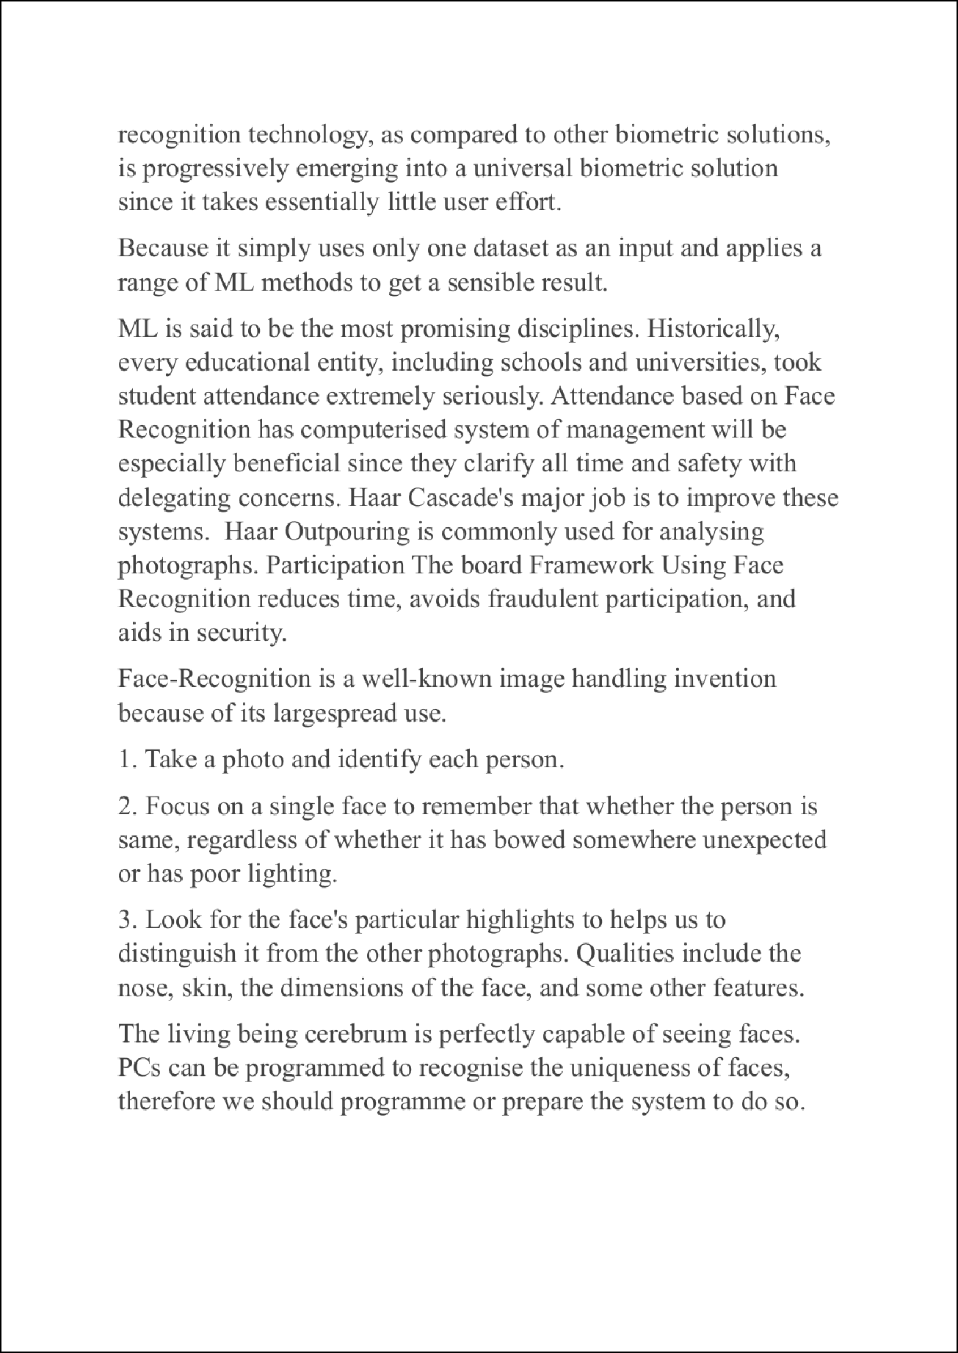

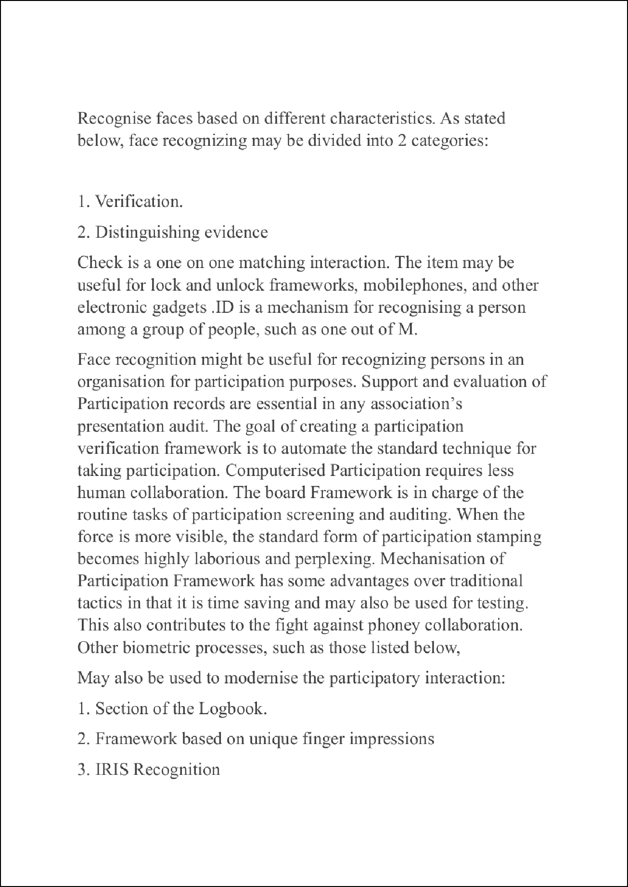

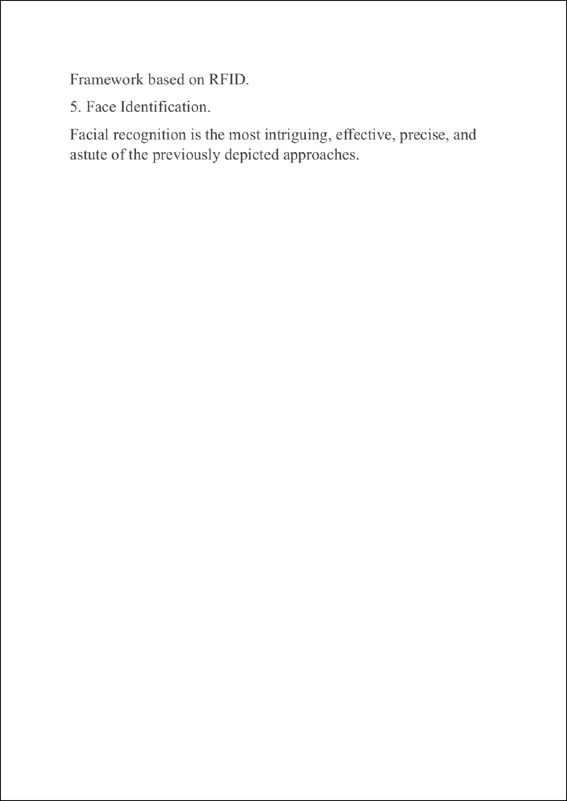

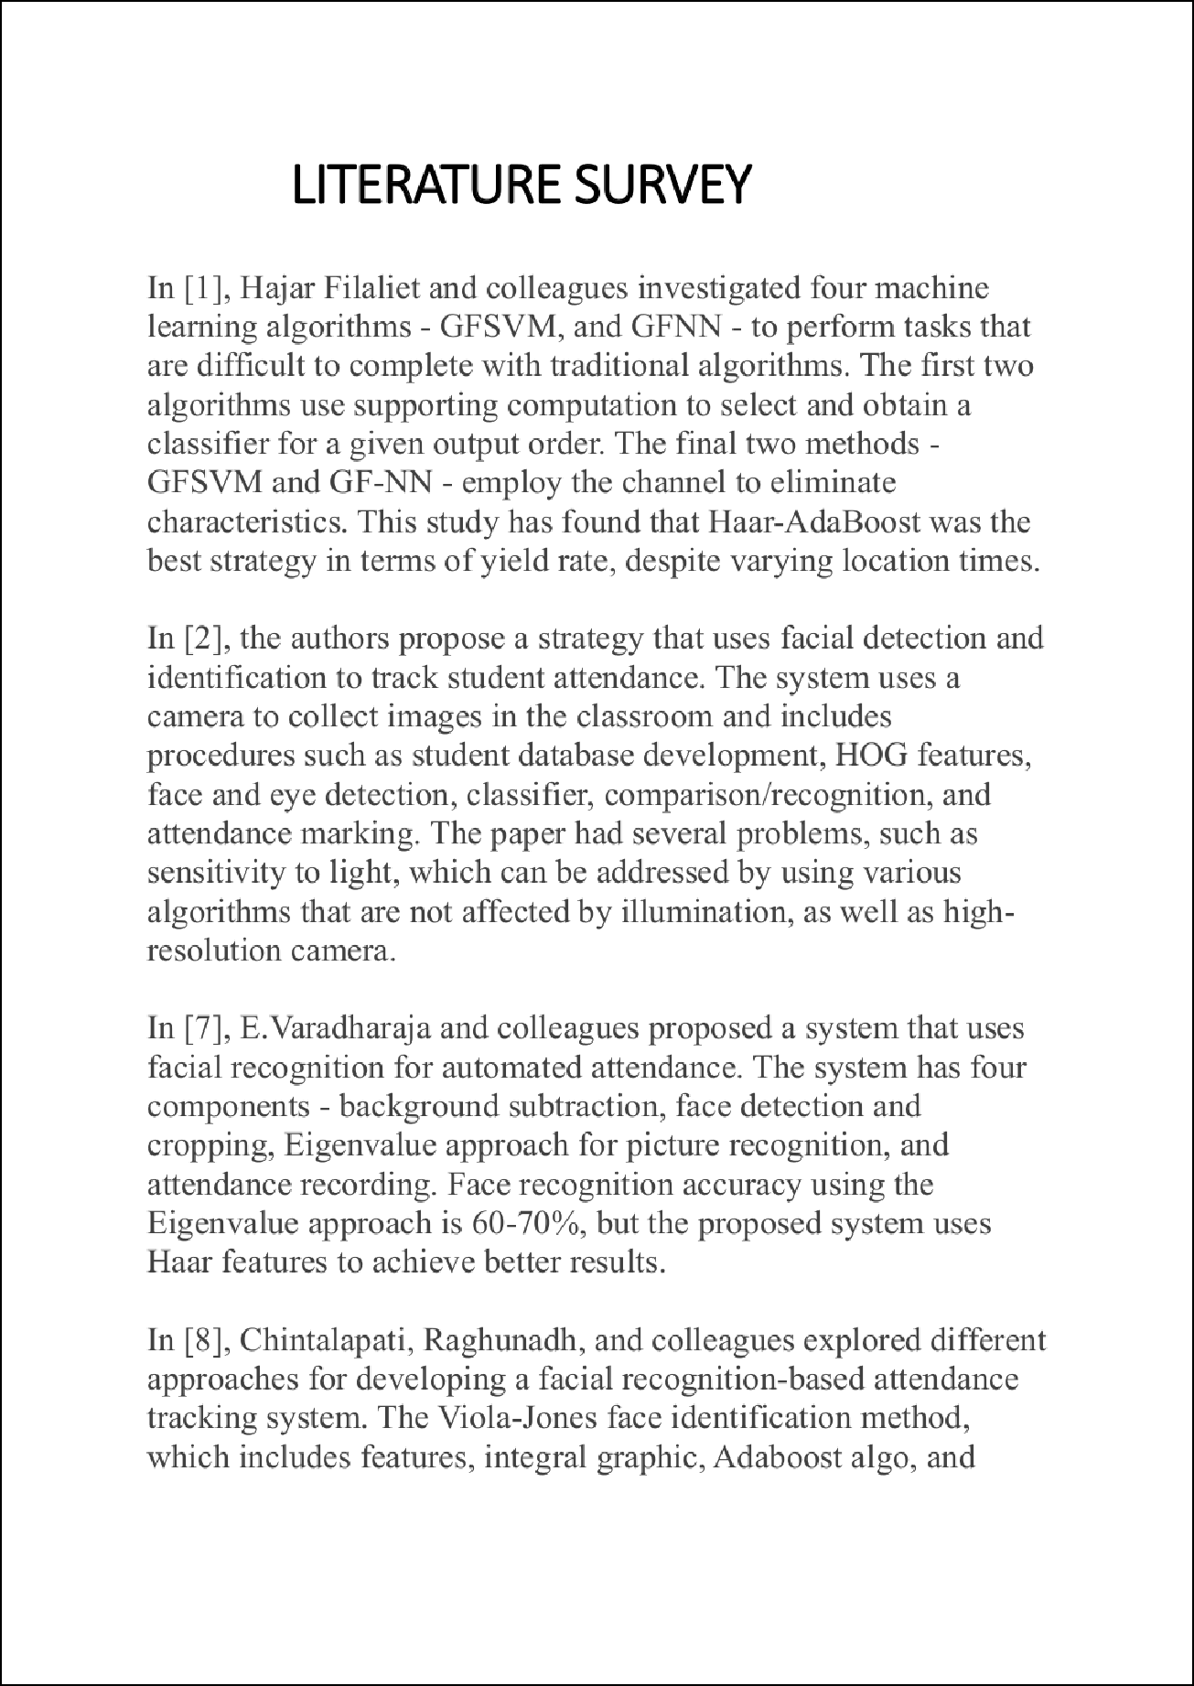

1

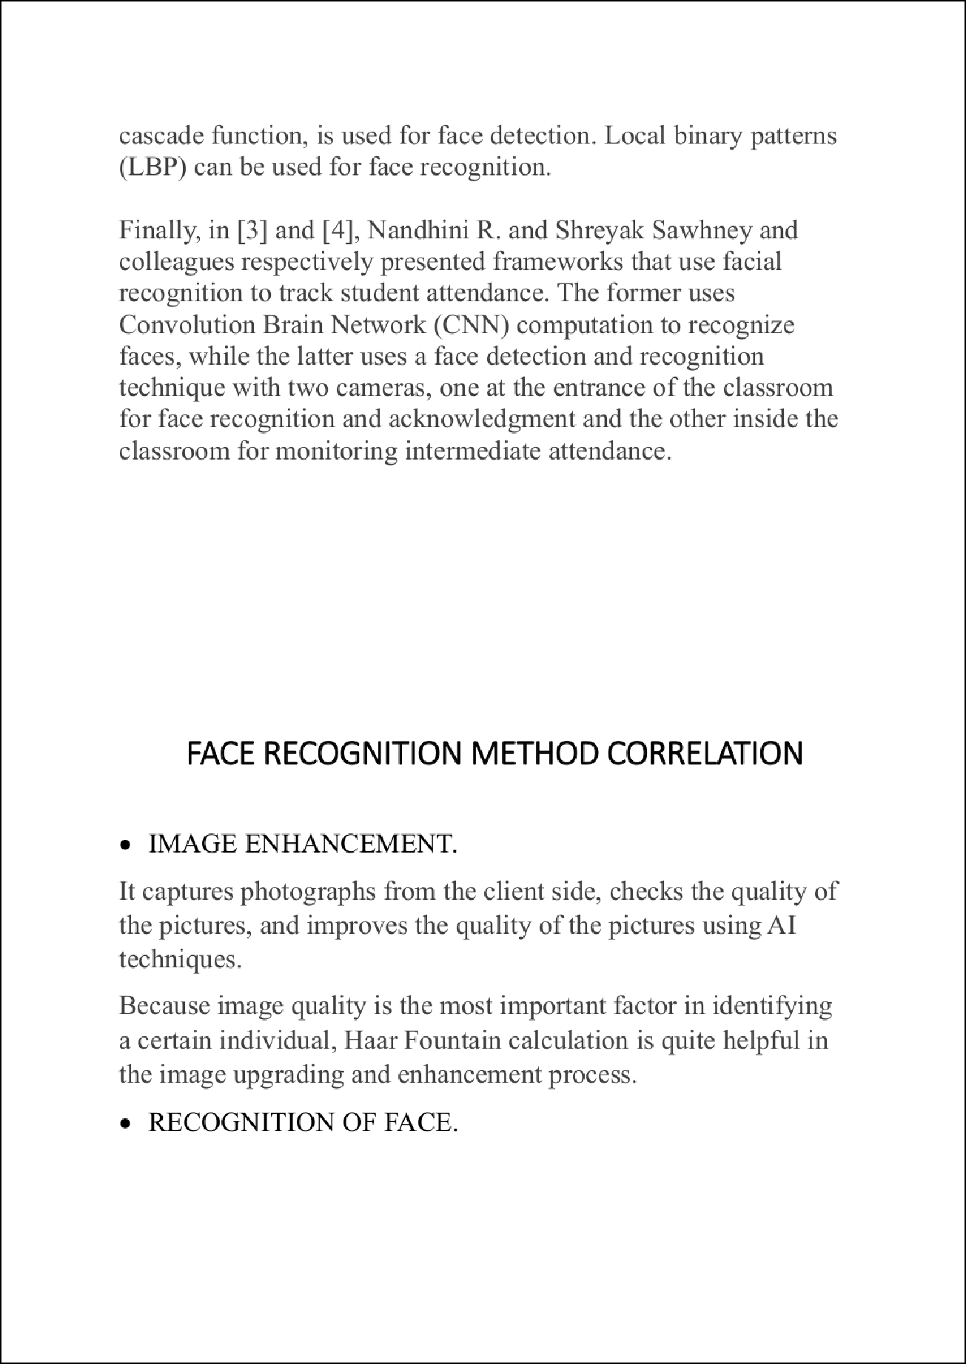

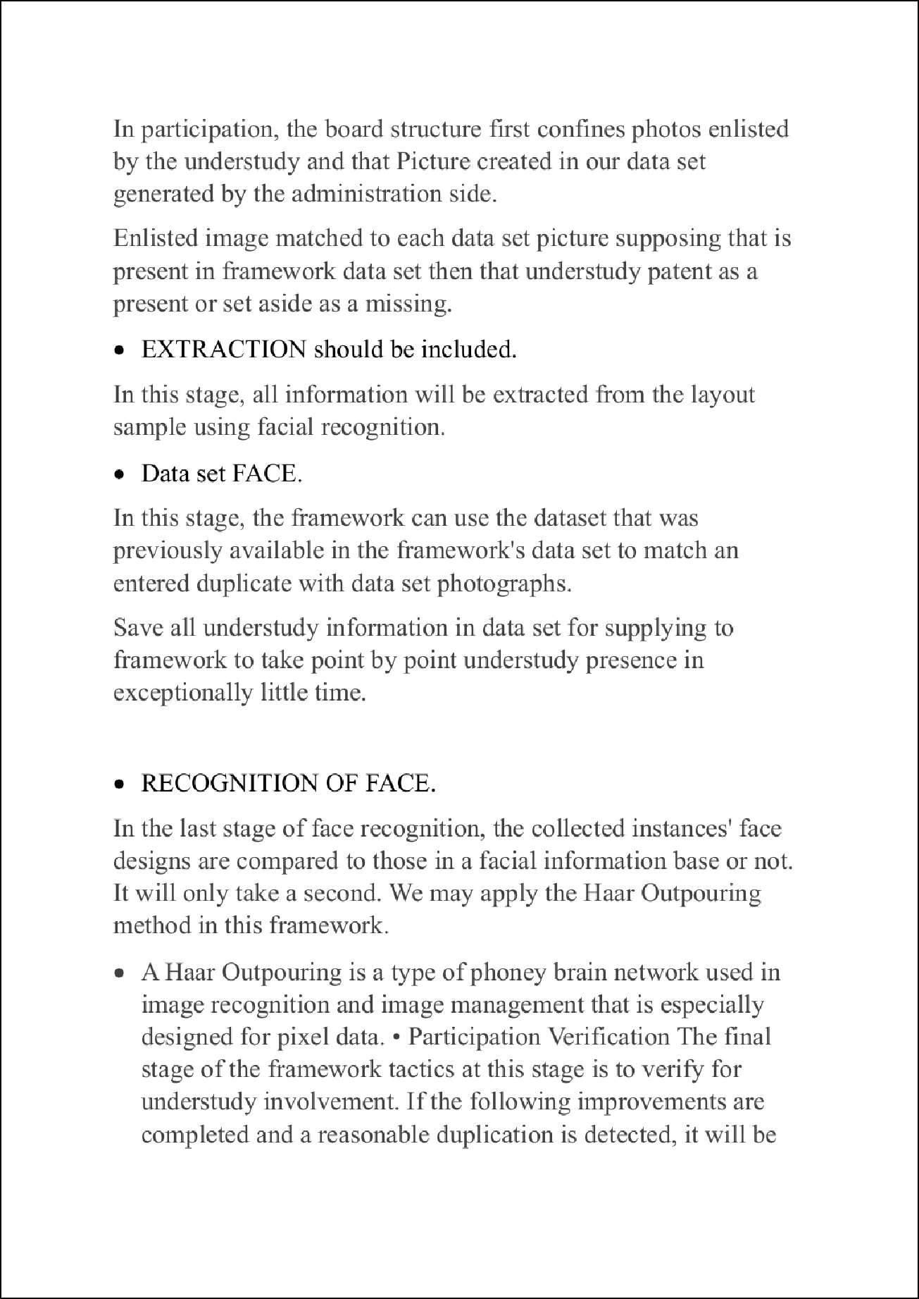

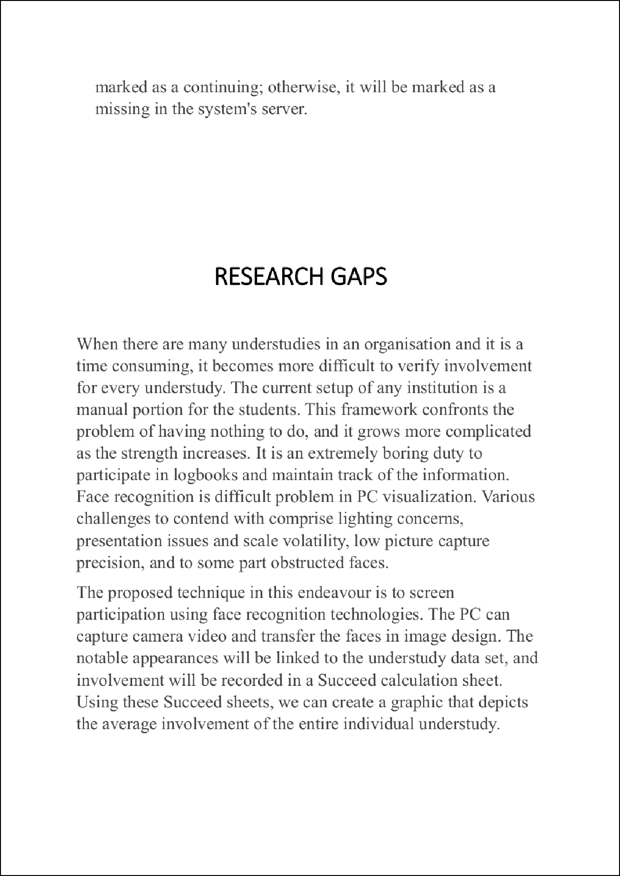

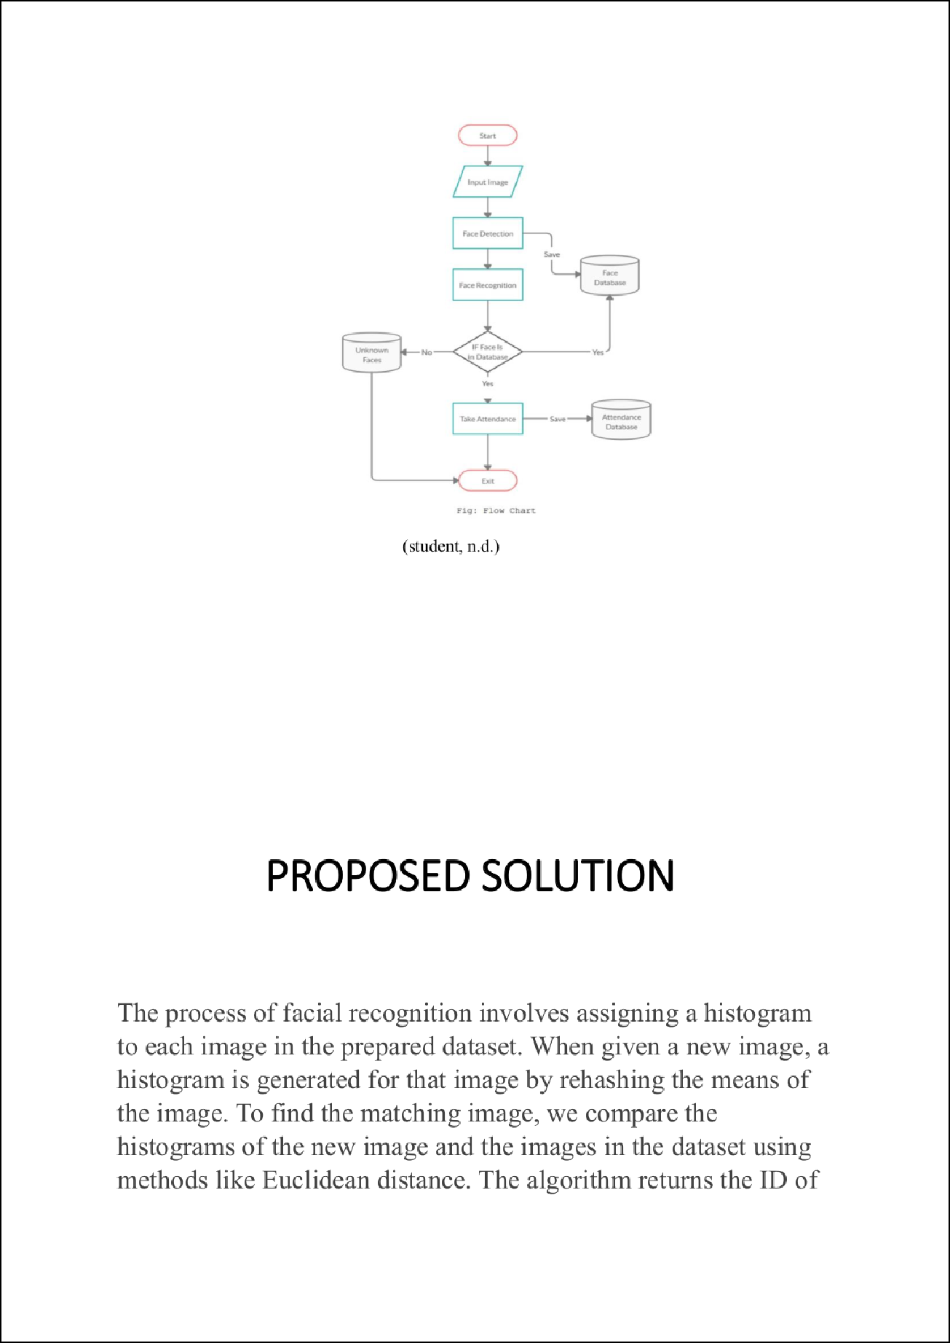

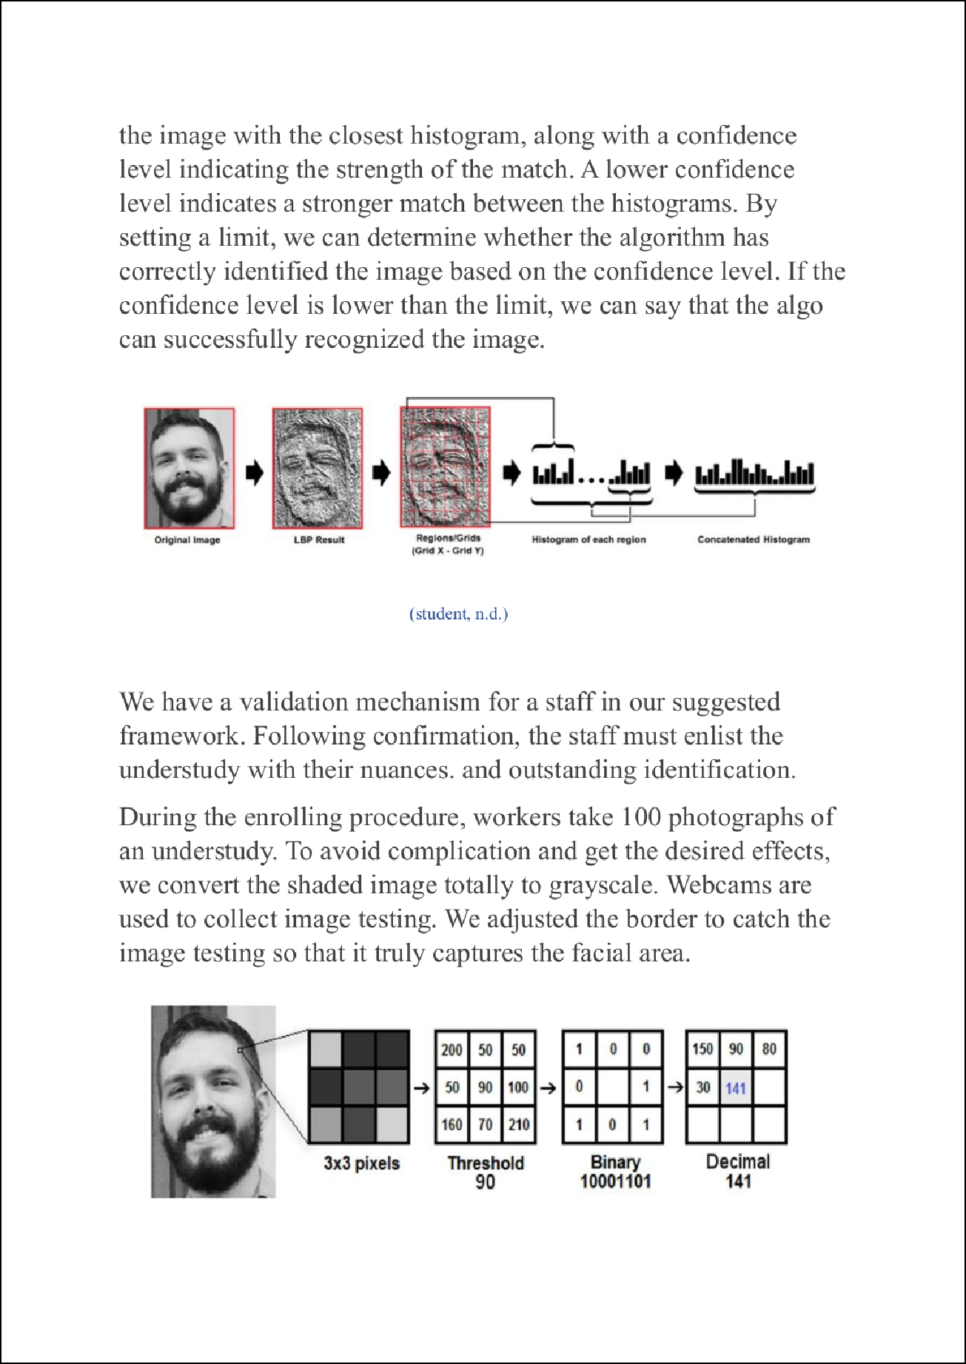

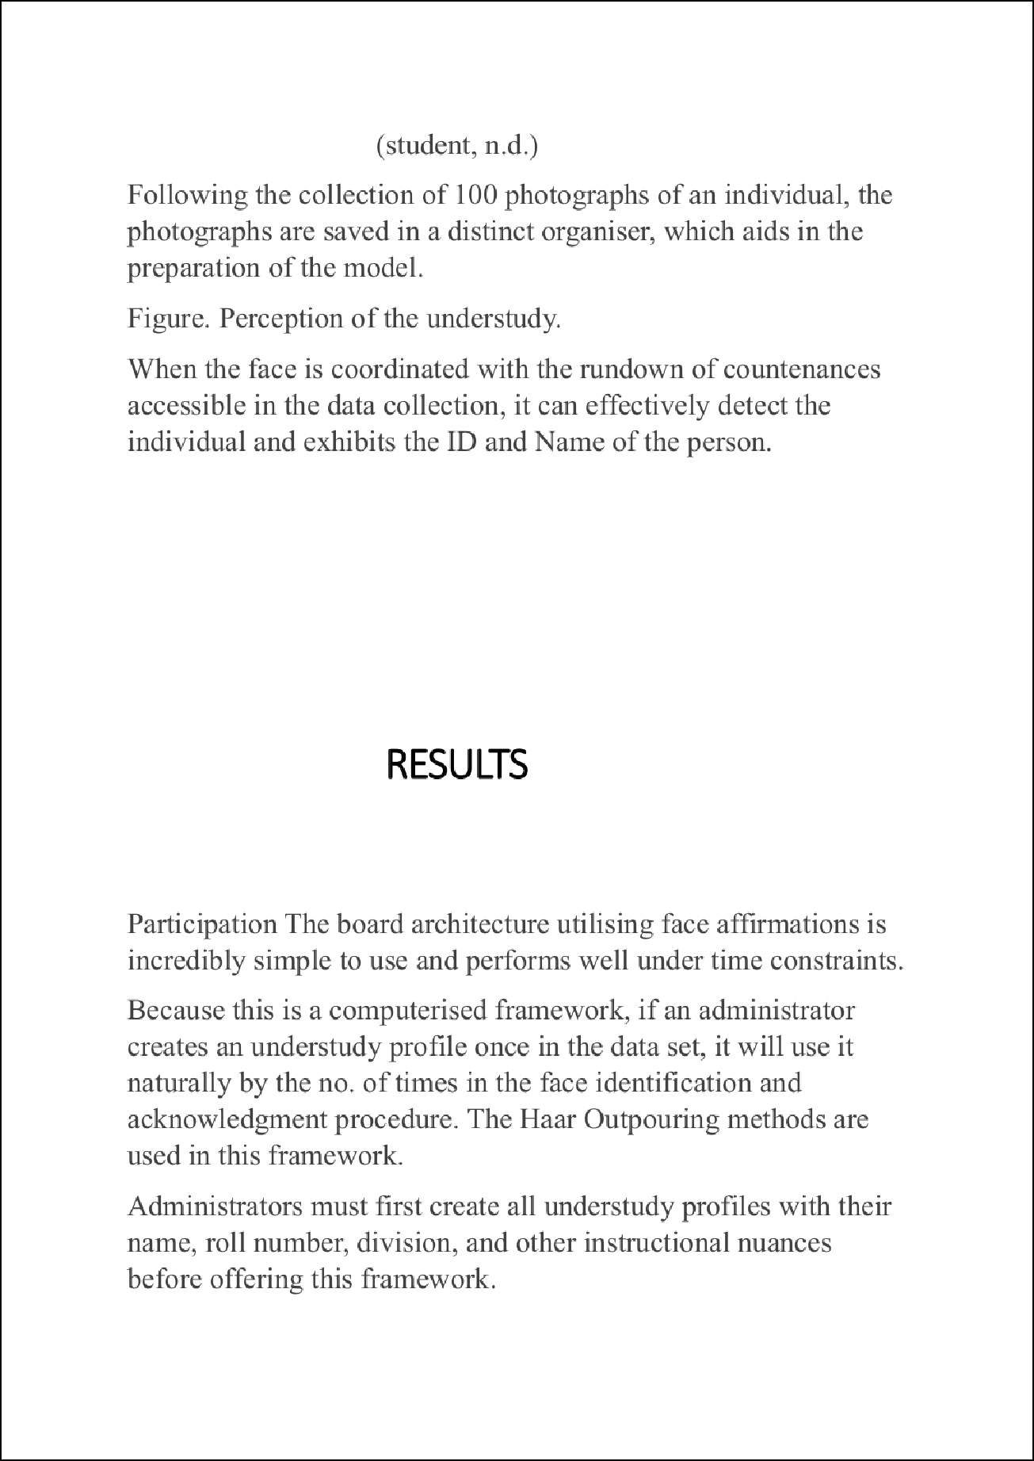

2

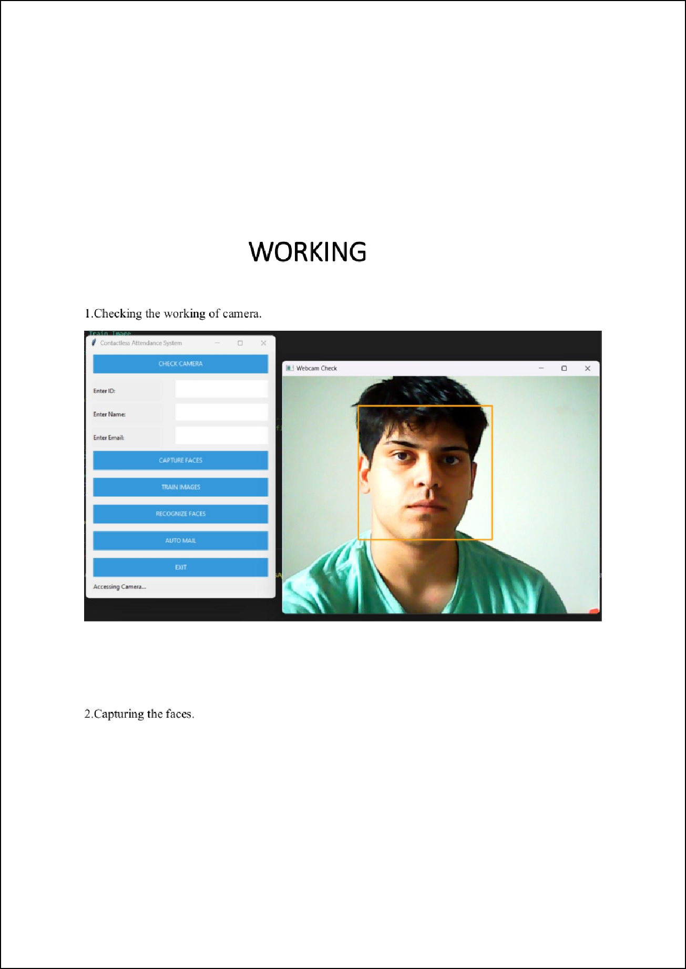

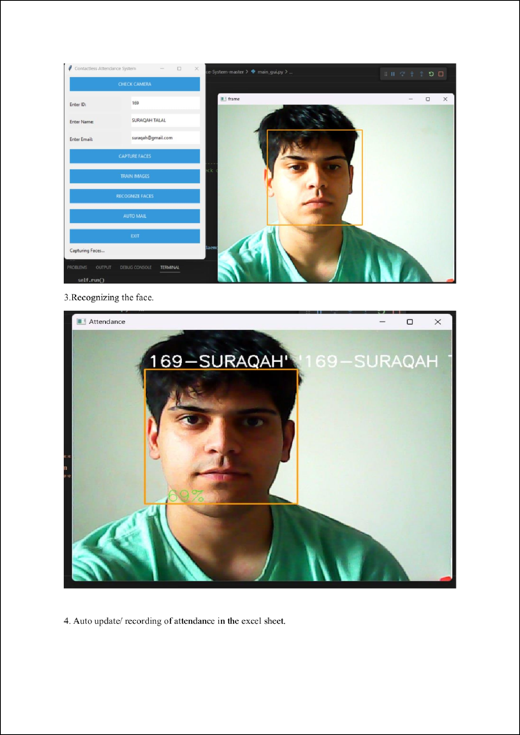

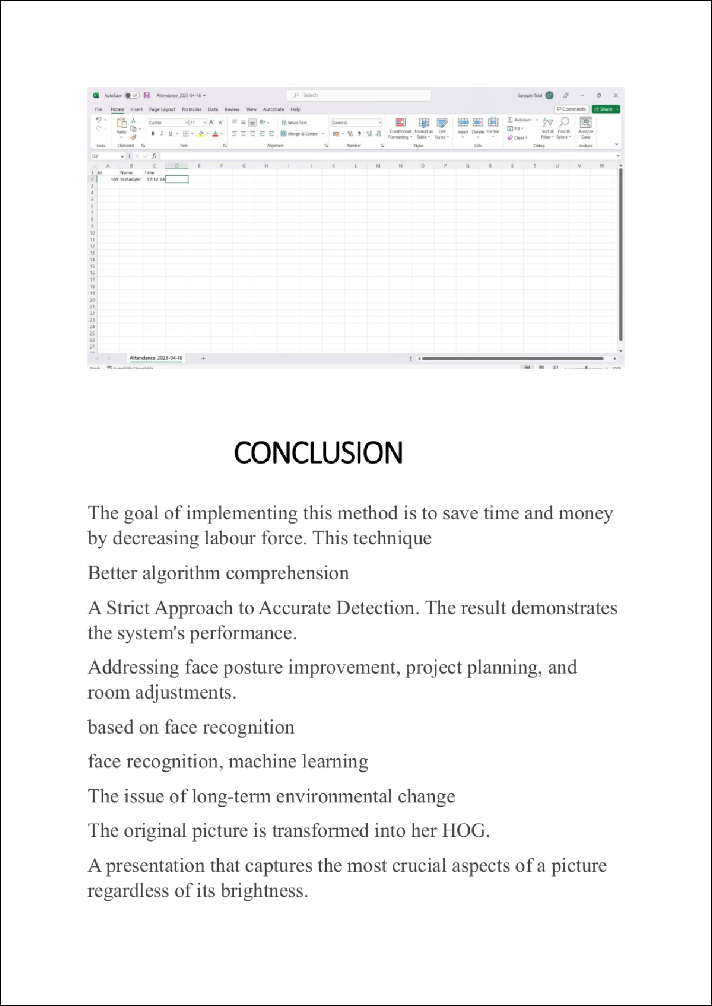

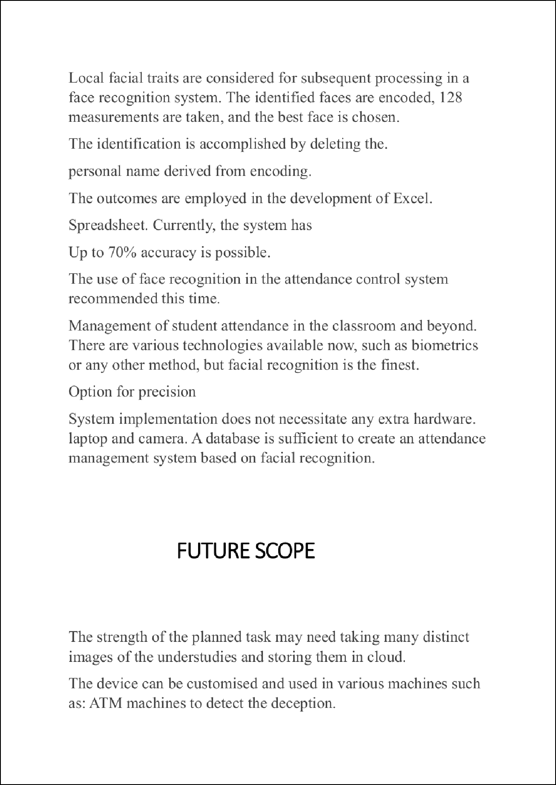

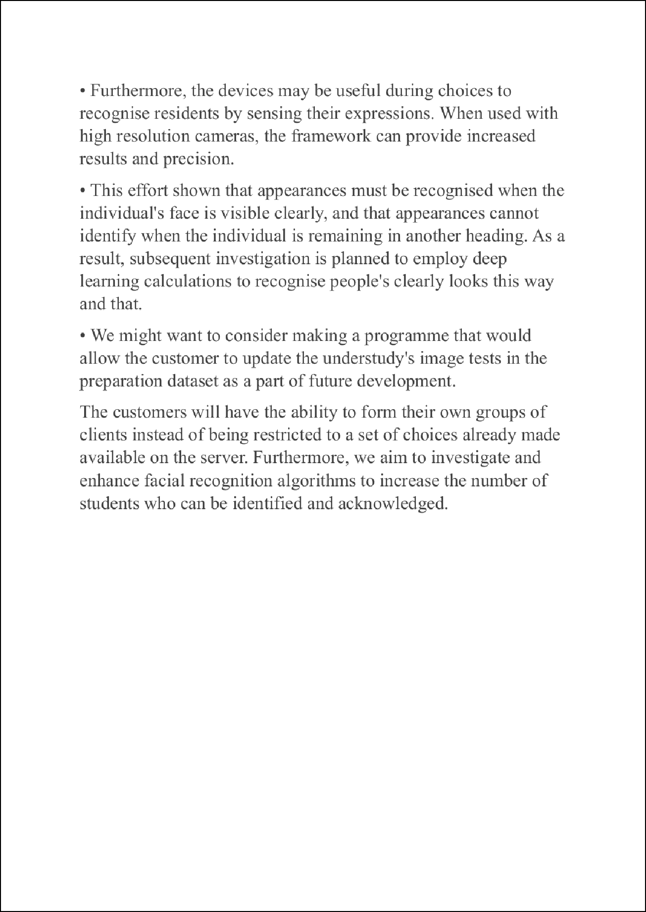

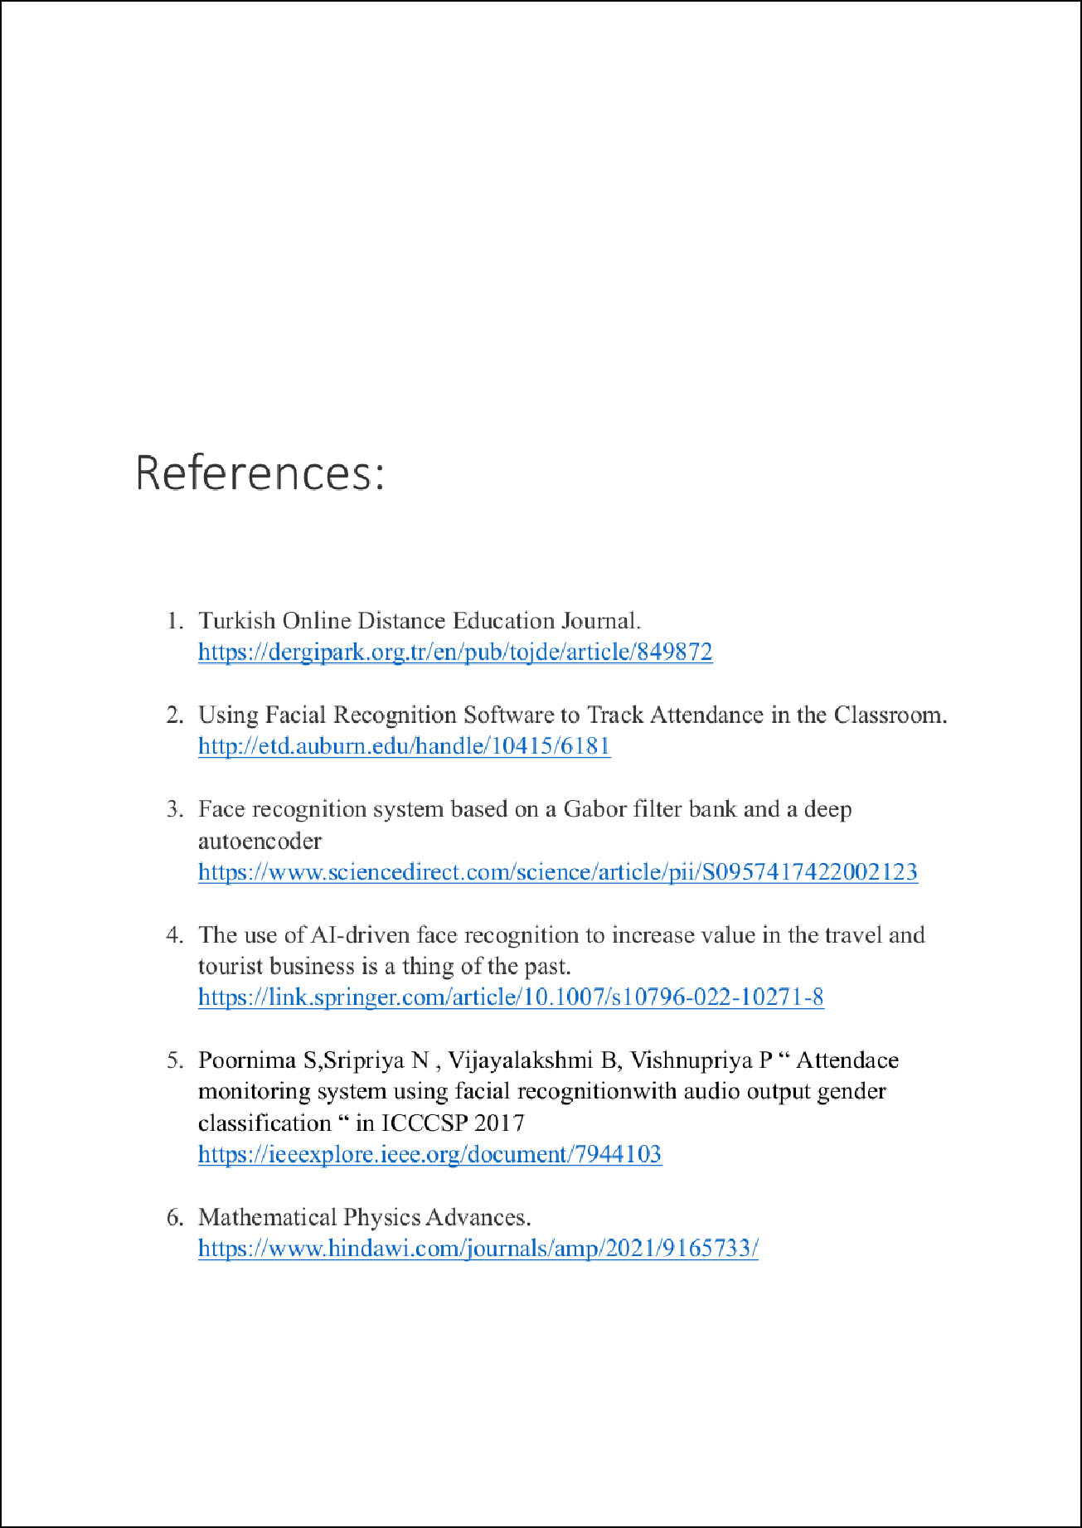

## PBL

ORIGINALITY REPORT

1

## %

SIMILARITY INDEX

0%

INTERNET SOURCES

0%

PUBLICATIONS

1%

STUDENT PAPERS

PRIMARY SOURCES

# Submitted to BITS, Pilani-Dubai

1

Student Paper

# [www.ijiemr.org](http://www.ijiemr.org/)

2

Internet Source

1%

<1%

Exclude quotes On Exclude bibliography On

Exclude matches Oﬀ